Global History Homework – Due Friday, 9/16

Create index cards for the following terms. Each index card must be created in the format below.

Historian  Anthropologist | Archaeologist  Political Scientist | Economist  Sociologist | Geographer
Sample front of card: Sample back of card:
Archaeologist
Define term:  a person who studies of the remains of  past human lives and activities | Key words related to term:  artifacts  excavation
Sentence:  Archaeologists use artifacts to understand the culture of people who lived in the past. | 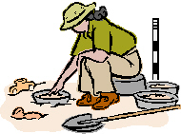  Illustration:

Global History Homework – Due Friday, 9/16

Create index cards for the following terms. Each index card must be created in the format below.

Historian  Anthropologist | Archaeologist  Political Scientist | Economist  Sociologist | Geographer
Sample front of card: Sample back of card:
Archaeologist
Define term:  a person who studies of the remains of  past human lives and activities | Key words related to term:  artifacts  excavation
Sentence:  Archaeologists use artifacts to understand the culture of people who lived in the past. | Illustration:

